|  |  |
| --- | --- |
| **Passive Optical Components** | **Optical Fiber Assembly** |
|  |  |

The theory of the outdoor cable assembly is same as that of the connectors. After stripping, through fan-out kit, the multi-core cable is divided into several bundle cables. Flexible metal tubing on the branched cables can improve the mechanical property and environmental suitability. The matched connectors could be customized. It is mainly used on the optical modules near the base stations.

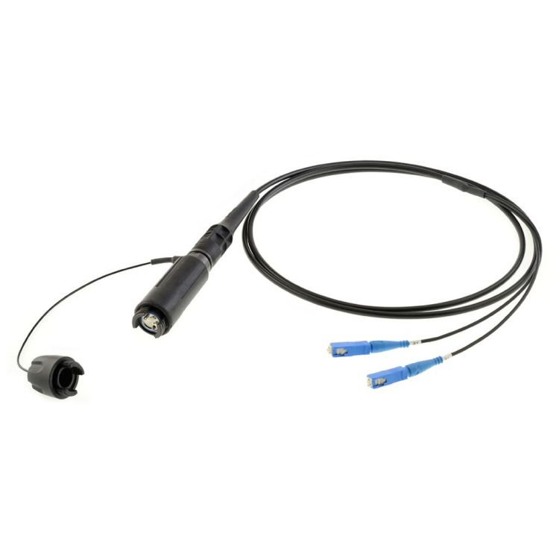

FEATURES

* **Optical fiber could choose single core ,dual-core or multi-core by customized；**
* **Branched Splitter is made of nylon with strong weather ability. It makes the branched optical cable good air-tightness and rain-proof function；**
* **G657A or customized type is usually used；]**
* **Optical cable’s jacket is made of LSZH material with smooth surface. And rat proof material is also used in the cable’s jacket which could widely used at outdoor base station；**
* **Branched cable is protected by armor flexible metal tubing which could resist the damage of torsion, pull, pressure and rats.**
* **Surface shall be smooth, clean, no oil pollution and burr-free.It have to be good consistency with no scar and no crack. All parts assemble smoothly, connectors and adapters match smooth-going and easily when inserting in and pulling ou**

|  |  |  |  |
| --- | --- | --- | --- |
| **Parameters** |  |  | **Conditions** |
|  |  |  |  |
| **Operating Temperature** |  |  | -40℃～+80℃ |
|  |  |  |  |
| **Storage Temperature** | | | -40℃～+80℃ |
|  | | |  |
| **Atmospheric Pressure** |  |  | 70Kpa～106Kpa |
|  |  |  |  |
| **Operating Wavelength** | | | 1310nm, 1550nm |
|  | | |  |
| **Insertion Loss** |  |  | ≤0.3dB |
|  |  |  |  |
| **Return Loss** | | | PC≥45dB UPC≥50dB APC≥60dB |
|  | | |  |
| **Repeatability** |  |  | ≤0.2dB |
|  |  |  |  |
| **Interchangeability** | | | ≤0.2dB |
|  | | |  |
| Be accordance with the national standard and communications standard | | |  |
|  |  |  |  |